Would like to invite you to the

Annual Dinner
Friday 16 May 2025
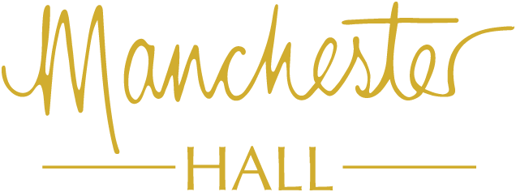

36 Bridge Street, Manchester, M3 3BT
- Champagne Reception
- Dinner and Live Band
- Charity Raffle
- Dress code: Black Tie Formal

This year’s nominated charity is:

Bar opens: 6.30pm, Dinner served 7.30pm,
Carriages at 12:00am

